Do Higher Alcoholic Beverage Sales Affect Life Expectancy?

A provincial analysis

Erin O'Toole

2020

## Introduction

Alcohol is used widely throughout the world as a means of recreation; however, the consequences of overconsumption are often unexpected and can be severe. According to the National Institute on Alcohol Abuse and Alcoholism, drinking too much alcohol, either at once or over time, interferes with the brain’s communication pathways and can affect both the way one’s brain looks and works. This results in mood swings, strange behavior, less coordination and difficulty with motor control.

In looking for datasets to use in my open data project, I found a multitude of tables related to alcohol consumption in Canada. I wondered what type of overall trends are connected to this consumption and after a thorough search of the Government of Canada’s Open Data Portal, I was able to refine this broader question to:

1. Does a higher volume of alcoholic beverage sales cause a lower life expectancy in Canada?

## The Data

The first dataset I used is titled *Volume of Sales of Alcoholic Beverages in Litres of Absolute Alcohol and per Capita 15 years and over, fiscal years ended March 31.* It spans the years 1989 to 2013. The dataset breaks down the type of alcohol sales in litres (spirits, wine and beer) per capita, per year for each province/territory of Canada. It also provides the grand total per year/beverage for the country of Canada as a whole. There was a lot of data included in this table, to narrow it down and make comparison easier I only used the year, province and total per capital sales of all alcoholic beverages (spirits, beer and wine combined) in my analysis.

The second dataset I chose is titled *Contribution of Selected Causes of Death to Changes (over 1, 5, 10 years) in life expectancy at birth, by sex.* The data is spread out over two ranges of dates: 2014-2016 and 2015-2017 and provides the difference in life expectancy for each range going back one year, five years and 10 years. It provides a breakdown of different medical reasons that have led to the change in life expectancy and how they present for males and females. The data is presented by province/territory, and like the first dataset, for Canada as a whole. The breakdown of the causes of death that led to the change in life expectancy is quite robust, but as I am not delving into the affects of alcohol on each specific cause, I chose to utilize the total change in life expectancy per province to make the comparison broader. I also used the dates, geographical location and combined the values for both males and females.

## The Results

## Total Alcohol Sales by Volume

For both datasets I chose to visualize them in a bar graph, as it was easier to compare which provinces had the highest sales of alcohol on the first graph, and which provinces had the biggest change in life expectancy on the second. Both graphs use the same colour scheme, making it easier to see how they compare.

For alcohol sales I used the provinces for my columns and a sum of the litres sold for my rows. The data is filtered so that only the provinces/territories are displayed and not the values for Canada as a whole. I further filtered the information to only use the years 2011, 2012 and 2013. These years were chosen because while the dates from both datasets do not line up perfectly, this is the portion of time that overlaps. Finally, the data was filtered one last time to ensure that the total per capita sales are the only sales being visualized.

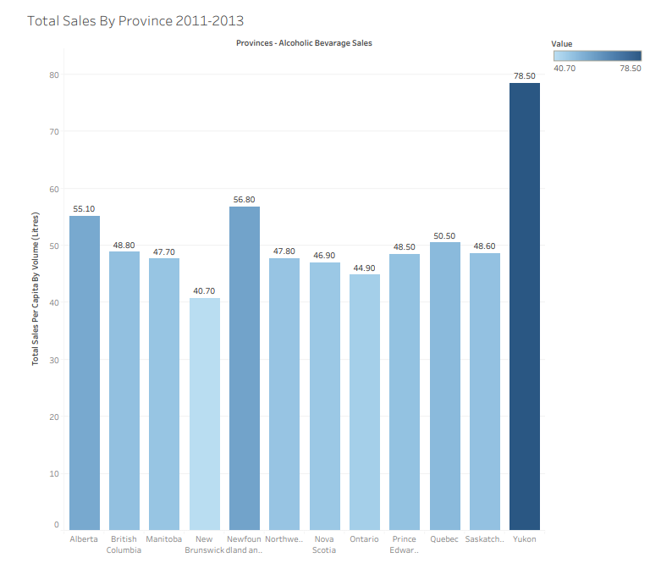

Figure 1.0: Total Sales By Province 2011-203

## Changes in Life Expectancy by Province

For the changes in Life Expectancy bar graph, I used the provinces as the columns and a sum of the change in life expectancy for the rows. I filtered the results to only show the 2014/2016 range, and further narrowed it down to use the data for the last five years. This means that the data shown is the total change in life expectancy over the last five years prior to the 2014/2016 date. These dates were chosen as they overlap with the first dataset. The other filters I chose were to show the life expectancy change for both sexes combined, all causes of death, and to exclude the Canadian total.

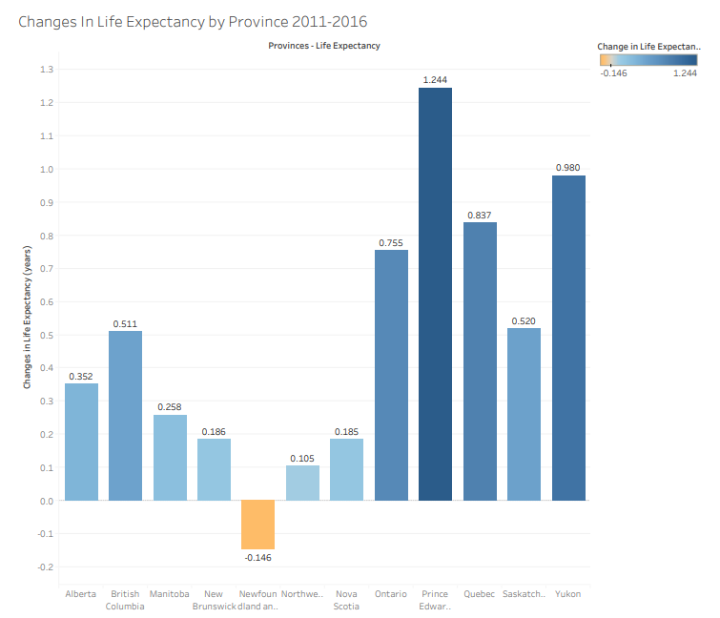

Figure 3.0: Changes in Life Expectancy by Province 2011-2016

In the first dataset, Northwest Territories and Nunavut are grouped together in the same geographical location. In order to properly compare both graphs, I created a dataset called Regular Provinces, which includes all provinces except for Northwest Territories and Nunavut. I then created a calculated field called Provinces – Life Expectancy, which checks to see if the province is included in Regular Provinces. If it is, then it is used as a location. If it is not, then it is added to ‘Northwest Territories with Nunavut’.

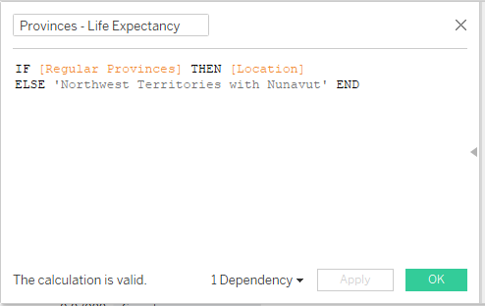

Figure 2.0: My calculated field titled ‘Provinces-Life Expectancy’

I then filtered the results by Provinces-Life Expectancy, which now included the combination of Northwest Territories and Nunavut. When viewing my bar graphs, they both have the same number of columns and can easily be compared at a glance.

## Analysis

I found there to be little correlation with alcoholic beverage sales and the change in life expectancy. Over the dates selected, Prince Edward Island had the largest increase in life expectancy, adding 1.244 years, with the next closest location being Yukon at 0.980 years. However, the sales of alcohol on the island were unremarkable and similar to the majority of the other provinces at 48.50. The only province to see a decrease in life expectancy was Newfoundland and Labrador, but while they had the second highest sale of alcohol at 56.80, they were not far ahead of Alberta at 55.10, who saw an increase in life expectancy of 0.352 years.

The most interesting comparison I found was Yukon with a life expectancy of 0.980 years added over the period of the dataset. When compared to total alcohol sales they by far have the most litres sold per capita at 78.50. My data shows that the highest total sales has the second highest life expectancy, however the second highest total sales as the worst life expectancy.

## Conclusion

Yukon and Newfoundland and Labrador are two remote locations within Canada. They are the two highest ranking provinces/territories for total alcohol sales but vary drastically in the change in their life expectancy. Did higher alcohol consumption cause the territory of Yukon to increase its life expectancy? As this relationship was not replicated in any other province/territory it is extremely unlikely that this is the cause. The most obvious conclusion to draw from this research is that there is no connection to how much alcohol a geographic location purchases and their life expectancy. Increased access to medical care, nutrition counselling, or even increase workplace safety standards could increase life expectancy while an aging population and public health concerns such as the obesity epidemic could decrease it.

In conclusion, I believe that further research is needed to better understand why these changes in life expectancy took place, and also what affect alcoholic beverage sales has on the population.

Sources

## Introduction

<https://www.niaaa.nih.gov/alcohols-effects-health/alcohols-effects-body>

## Datasets

<https://open.canada.ca/data/en/dataset/6168fcf1-5dbc-4216-b6ce-a7672562a840>

<https://open.canada.ca/data/en/dataset/7757182b-0f9b-4c56-b7e1-10cf7a8fcacd>